41.12: a) the lowest possible value of 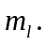
c)
